**CREATING A BRAND NAME, BRAND EMAIL AND BRAND LOGO USING WORDPRESS**

1. **INTRODUCTION**

**1.1 *Brand Name*:** STAR LORD

* 1. ***Category*:** AI BLOG
  2. ***Brand Email*:**starloard[@gmail.com](mailto:hungryhubrestaurants@gmail.com)
  3. ***Overview***

In this project, is going to be creating Brand Name, Brand Email and Brand Logo using

Wordpress. After publish it is going to be uploaded in Github.

* 1. ***Purpose***

The purpose of the project is learnt how to create a Brand Name, Brand Email and Brand Logo using Wordpress for digital marketing. Because Word Press is a easy platform to create a logo and edit it.

1. **PROBLEM DEFINITION AND DESIGN THINKING**
   1. ***Empathy map***

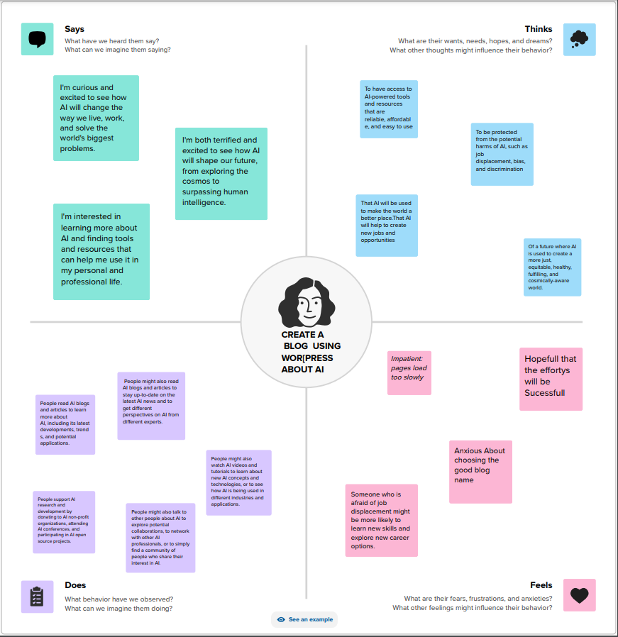

* 1. ***Ideation & Brainstormimg***

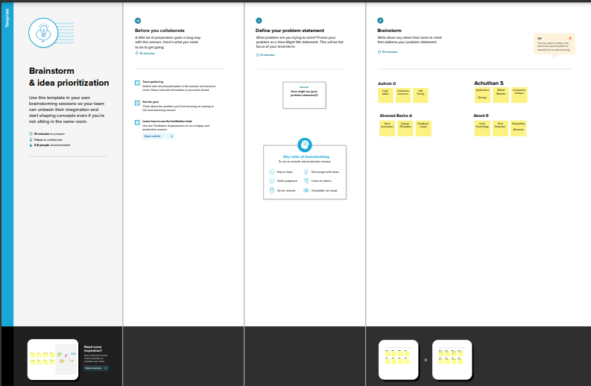

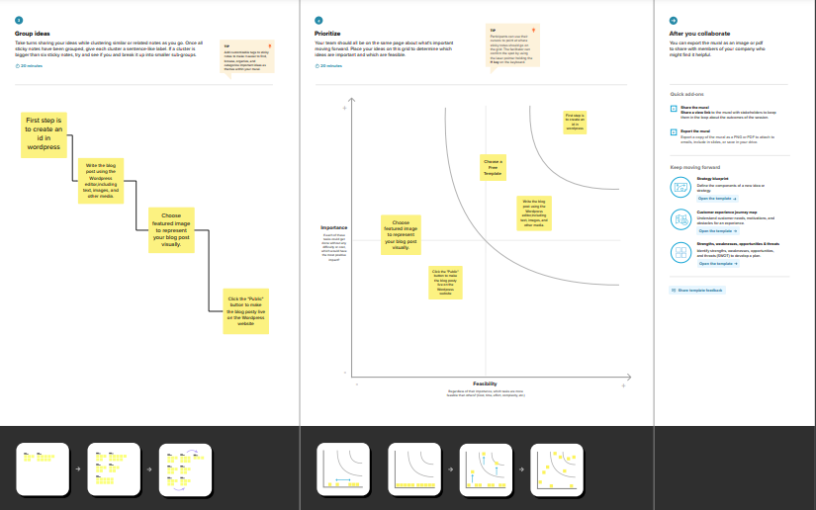

1. **RESULT**

***LOGO*:**



1. **ADVANTAGES**
2. AI is highly accurate and its use reduces human error.
3. AI can easily handle and process Big Data.
4. Pattern Identification.

**DISADVANTAGES**

1. High Costs
2. No Creativity
3. Unemployment
4. No Ethics
5. **APPLICATION**

The major applications of AI are in E-Commerce, Education, Robotics, Healthcare, social media, etc**.**

1. **CONCLUSION**

AI leads to transformative applications within a series of industrial, intellectual, and social applications, far beyond those caused by previous industrial revolutions.